**CHAPTER II**

**BASIC OF THEORY**

**II.1 Definition of Oculus Rift**

Oculus Rift is a technology that allow users to interact with real objects being simulated using a computer. Actually, Virtual memory is the environment / objects that exist only in the imagination that is capable of generating three-dimensional atmosphere that makes the user as if physically involved.

Oculus Rift connect between real life and virtual world. With this tool people can interact in virtual world. This technology bring many advantages for our life, any problem which need a big funds or wide place will be handled with this technology. This technology is able to make people who play in the virtual world to believe that they are in the real world.

Example: flight simulation.

Pilots can use a virtual reality system to perform flight simulation before the actual flight.

**II.2 History of Oculus Rift**

Oculus rift created by Palmer Luckey. Beginning of making the oculus is only intended to gamers.when initial appearance, he gets donation from Backer (donors) who are mostly maniac game and indeed Oculus Rift is intended only to play game. Then the main vision is "one step to get into the game real world" since the user will feel really be in the game world.

On 25 March 2014 Oculus VR bought by Facebook for US $ 2 billion. $ 400 million in cash, the rest in shares form. People worry if Facebook buy Oculus VR, the development will be not for game again. But Mark Zuckeberg said that Oculus VR will be helped by Facebook Company at software section only, not at hardware section. Zuckeberg thinks this tool will be a strong candidates as social platform and communication at the future.

**III.3 Components of Oculus Rift**

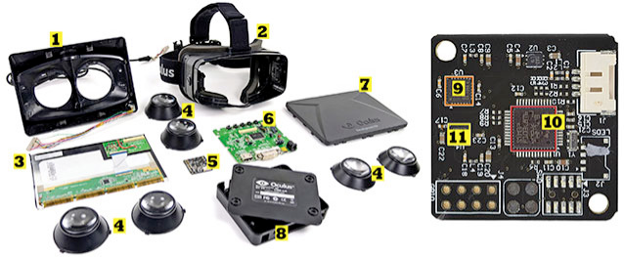

Figure 2.1 Components of Oculus Rift

(REF: <http://eandt.theiet.org>)

There are 11 part inside Oculus Rift :

1. **Lens mounting**

The usefulness of this lens as a convex lens placed.

1. **Headset**

This part is body of lens mounting placed. When you use Oculus Rift, you also look inside this part like using glasses.

1. **LCD Board**

This part functions is to displaying an image,text and menus on Oculus Rift.

1. **Lenses (multiple options)**

This part function is to displaying an image through a lens. When small image viewed without the oculus rift, will be big when you use Oculus Rift. This is the effect of a convex lens which used as a lens.

1. **Adjacent Reality Tracker Board**

This part function is to regulate the movement of the sensor head. In this part there Gyro / accelerometer InvenSense, Microcontroller STMicroelectronics and Magnetometer.

1. **Control Box Board**

This part function is controlling the choice which we choose and confirmation to the system when we choose a choice.

1. **Lens mounting cover**

This part is a cover of the lens and headset. This cover protects the components inside from the front, in this part there is also LCD Board which display an image.

1. **Control Box Container**

This part also serves as a lens cover, protects the control board that serves as a control in the oculus rift.

1. **Gyro sensor / Accelerometer Invense**

Accelerometer Invense sensor is required to change the display orientation from vertical to horizontal or vice versa. While the gyro sensor is a sensor for measuring or maintaining orientation, with the provision of angular momentum principle.

1. **Microcontroller ST Microelectronics**

Microcontroller is a functional system on a chip. It contains a processor core, memory (a small amount of RAM, program memory, or both), and input and output equipment.

1. **Magnetometer**

This part serves as a button to choose a choice. When you look at the choice and press this button, your choice will be displayed.

**II.4 Version of Oculus Rift**

There are 6 version of Oculus Rift :

1. **Oculus Rift HD Prototype**

This is the first generation of Oculus Rift. This stuff is not for sell but for Development of Oculus Rift. This is a start of Oculus Rift to evolve.

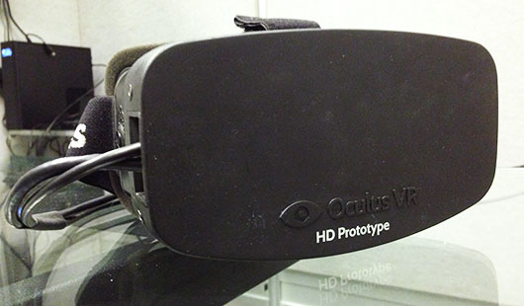

Figure 2.2 Oculus Rift HD Protoype

(REF: [www.oculus.com](http://www.oculus.com))

1. **Oculus Rift Developer Kit**

This is the development of Oculus Rift from HD Prototype. The design was very simple but the performance is better than HD prototype. But when this item on sale, game developers side give a feedback about many bugs when this item used.

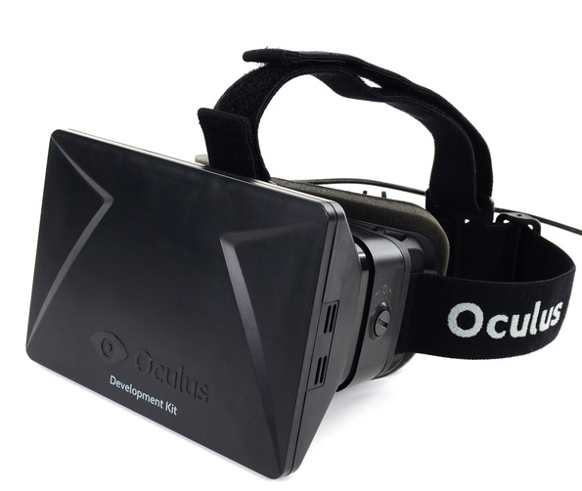

Figure 2.3 Oculus Rift Developer Kit 2

(REF: [www.display-central.com](http://www.display-central.com))

1. **Oculus Rift Developer Kit 2**

This is development of the first Developer Kit. There are many improvements in this version. an example is the increase in visual section which more stable and many bugs resolved.

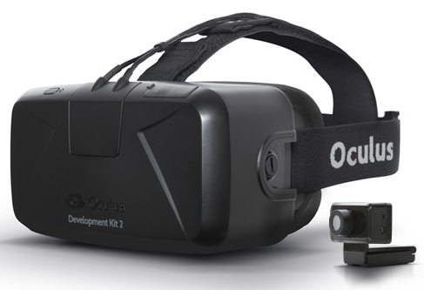

Figure 2.4 Oculus Rift Developer Kit 2

(REF: www1.oculus.com)

1. **Oculus Rift Crystal Cove Prototype**

Crystal Cove Prototype is not much different from the Developer Kit 2, but the more comfortable than Developer Kit 2 version. This version improve at comfort side because this version is a final version improvement to be published for all gamer.

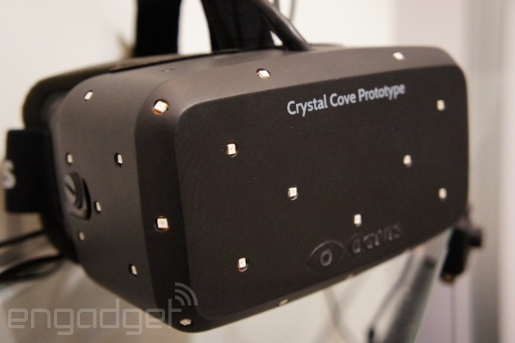

Figure 2.5 Oculsu Rift Crystal Cove Prototype

(REF: [www.engadget.com](http://www.engadget.com))

1. **Oculus Rift Consumer Version**

Oculus Rift Consumer Version is a product which sold for gamers and game developers. In this version, all bugs in previous versions have been fixed and the visual has been increased to make gamers more comfortable. Elegant design in this version also makes many people want to have it.

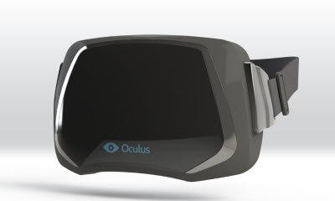

Figure 2.6 Oculus Rift Consumer Version

(REF: <http://venturebeat.com/>)